Dynamixel AX-12A Robot Servo
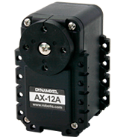
- 15 kgcm torque (12V)
- 59rpm
- 300 Grad Stellwinkel
- RS232 TTL single wire bus (siehe Manual), daisy chainable
- meldet Position, Geschwindigkeit, Stromaufnahme, Temperatur
- 9-12V (9,6V empfohlen)
- 55gr Gewicht
- maximale Stromaufnahme 1.5A
- Weight : 53.5g (AX-12/AX-12+), 54.6g (AX-12A)
- Dimension : 32mm * 50mm * 40mm
- Resolution : 0.29°
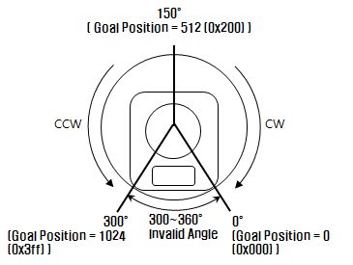
- Gear Reduction Ratio : 254 : 1
- Stall Torque : 1.5N.m (at 12.0V, 1.5A)
- No load speed : 59rpm (at 12V)
- 0° ~ 300°, Endless Turn
- Running Temperature : -5℃ ~ +70℃
- Voltage : 9 ~ 12V (Recommended Voltage 11.1V)
- Command Signal : Digital Packet
- Protocol Type : Half duplex Asynchronous Serial Communication (8bit,1stop, No Parity)
- Link (Physical) : TTL Level Multi Drop (daisy chain type Connector)
- ID : 254 ID (0~253)
- Communication Speed : 7343bps ~ 1 Mbps
- Feedback : Position, Temperature, Load, Input Voltage, etc.
- Material : Engineering Plastic

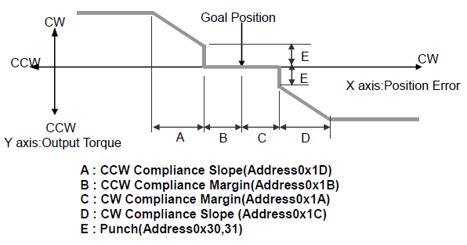
Baud Rate
Data | Set BPS | Target BPS | Tolerance
1 | 1000000.0 | 1000000.0 | 0.000 %
3 | 500000.0 | 500000.0 | 0.000 %
4 | 400000.0 | 400000.0 | 0.000 %
7 | 250000.0 | 250000.0 | 0.000 %
9 | 200000.0 | 200000.0 | 0.000 %
16 | 117647.1 | 115200.0 | -2.124 %
34 | 57142.9 | 57600.0 | 0.794 %
103 | 19230.8 | 19200.0 | -0.160 %
207 | 9615.4 | 9600.0 | -0.160 %

void CDS5500:: WritePos(int ID, int position, int velocity)
{
int messageLength = 7;
byte pos2 = position/255;
byte pos = position%255;

byte vel2 = velocity/255;
byte vel = velocity%255;

printf(startByte); // send some data
printf(startByte);
printf(ID);
printf(messageLength);
printf(INST_WRITE);
printf(P_GOAL_POSITION_L);
printf(pos);
printf(pos2);
printf(vel);
printf(vel2);
printf((~(ID + (messageLength) + INST_WRITE + P_GOAL_POSITION_L + pos + pos2 + vel + vel2))&0xFF);
}

http://support.robotis.com/en/product/dynamixel/ax_series/dxl_ax_actuator.htm

AX-12 Basics
Controlling the AX-12 servos is a snap. They use a serial bus and a very simple packet structure:

- Each packet begins with 2 start bytes, both of which will be value 255 (or 0xff for those who prefer hexadecimal)
- The next byte is the ID of the servo that you want to control. The servos included in the comprehensive kit are numbered 1-18. An ID of 254 is a broadcast, all servos will take the command -- be very careful with this, it's easy to mess stuff up.
- The next byte is the length of the packet
- The next byte is the instruction to carry out. Instructions include: Ping, Read, Write, and SyncWrite. For now, we'll only worry about Write.
- We then send any parameters.
- The last byte is a checksum. The checksum is a quick way to make sure the packet didn't get messed up in transit. We compute the checksum by adding up the ID, length, instruction, and all parameters, which I'll call SUM, then: checksum = 255 - (sum%256), so that we have an 8-bit number. If you send the wrong checksum, the servo won't do anything with the data recieved.
An AX-12 will typically return a status packet after you send a command, the packet structure is also very simple, it has the same start bytes, checksum, ID, and length. The instruction is replaced by the error level, and the parameters returned depend on the actual instruction sent.
We mentioned that the instructions we can carry out are mainly limited to Read/Write, so what are we reading and writing? The AX-12 uses a memory-mapped or register-based interface. Memory addresses (register addresses) correspond to particular parameters of operation. For instance, register #3 is the ID of the servo, if we write to this, the servo ID changes. The registers most of interest will be:
- #3 = ID. Servos in the comprehensive kit are already set to ID 1-18, if you buy a single servo though, the default ID of the new AX-12 is 1. Each servo on the bus needs it's own ID.
- #4 = Baud Rate. The default value is 1, which sets the baud rate to 1Mbps. Another common value you might use is 16, which gives us good old 115.2kbps.
- #30 & 31 = Goal position. This is the point we want the servo to go to, because the value is between 0 and 1023, we need 2 registers to hold our 10-bit value. Register 30 is the low byte, and register 31 is the high byte. Thus, 0 = 0x000, 512 = 0x200, 1023 = 0x3ff. For a value of 1023, register 30=0xff, register 31=0x03.
- #43 = Temperature. We can read back the current temperature of the servo, this is important because heat kills motors and electronics.

EEPROM

Address (Hex) | Name | Description | Access | Initial Value  (Hex)
0 (0X00) | Model Number(L) | Lowest byte of model number | R | 12 (0X0C)
1 (0X01) | Model Number(H) | Highest byte of model number | R | 0 (0X00)
2 (0X02) | Version of Firmware | Information on the version of firmware | R | -
3 (0X03) | ID | ID of Dynamixel | RW | 1 (0X01)
4 (0X04) | Baud Rate | Baud Rate of Dynamixel | RW | 1 (0X01)
5 (0X05) | Return Delay Time | Return Delay Time | RW | 250 (0XFA)
6 (0X06) | CW Angle Limit(L) | Lowest byte of clockwise Angle Limit | RW | 0 (0X00)
7 (0X07) | CW Angle Limit(H) | Highest byte of clockwise Angle Limit | RW | 0 (0X00)
8 (0X08) | CCW Angle Limit(L) | Lowest byte of counterclockwise Angle Limit | RW | 255 (0XFF)
9 (0X09) | CCW Angle Limit(H) | Highest byte of counterclockwise Angle Limit | RW | 3 (0X03)
11 (0X0B) | the Highest Limit Temperature | Internal Limit Temperature | RW | 70 (0X46)
12 (0X0C) | the Lowest Limit Voltage | Lowest Limit Voltage | RW | 60 (0X3C)
13 (0X0D) | the Highest Limit Voltage | Highest Limit Voltage | RW | 140 (0XBE)
14 (0X0E) | Max Torque(L) | Lowest byte of Max. Torque | RW | 255 (0XFF)
15 (0X0F) | Max Torque(H) | Highest byte of Max. Torque | RW | 3 (0X03)
16 (0X10) | Status Return Level | Status Return Level | RW | 2 (0X02)
17 (0X11) | Alarm LED | LED for Alarm | RW | 36(0x24)
18 (0X12) | Alarm Shutdown | Shutdown for Alarm | RW | 36(0x24)

RAM

24 (0X18) | Torque Enable | Torque On/Off | RW | 0 (0X00)
25 (0X19) | LED | LED On/Off | RW | 0 (0X00)
26 (0X1A) | CW Compliance Margin | CW Compliance margin | RW | 1 (0X01)
27 (0X1B) | CCW Compliance Margin | CCW Compliance margin | RW | 1 (0X01)
28 (0X1C) | CW Compliance Slope | CW Compliance slope | RW | 32 (0X20)
29 (0X1D) | CCW Compliance Slope | CCW Compliance slope | RW | 32 (0X20)
30 (0X1E) | Goal Position(L) | Lowest byte of Goal Position | RW | -
31 (0X1F) | Goal Position(H) | Highest byte of Goal Position | RW | -
32 (0X20) | Moving Speed(L) | Lowest byte of Moving Speed | RW | -
33 (0X21) | Moving Speed(H) | Highest byte of Moving Speed | RW | -
34 (0X22) | Torque Limit(L) | Lowest byte of Torque Limit | RW | ADD14
35 (0X23) | Torque Limit(H) | Highest byte of Torque Limit | RW | ADD15
36 (0X24) | Present Position(L) | Lowest byte of Current Position | R | -
37 (0X25) | Present Position(H) | Highest byte of Current Position | R | -
38 (0X26) | Present Speed(L) | Lowest byte of Current Speed | R | -
39 (0X27) | Present Speed(H) | Highest byte of Current Speed | R | -
40 (0X28) | Present Load(L) | Lowest byte of Current Load | R | -
41 (0X29) | Present Load(H) | Highest byte of Current Load | R | -
42 (0X2A) | Present Voltage | Current Voltage | R | -
43 (0X2B) | Present Temperature | Current Temperature | R | -
44 (0X2C) | Registered | Means if Instruction is registered | R | 0 (0X00)
46 (0X2E) | Moving | Means if there is any movement | R | 0 (0X00)
47 (0X2F) | Lock | Locking EEPROM | RW | 0 (0X00)
48 (0X30) | Punch(L) | Lowest byte of Punch | RW | 32 (0X20)
49 (0X31) | Punch(H) | Highest byte of Punch | RW | 0 (0X00)

